FOR IMMEDIATE RELEASE

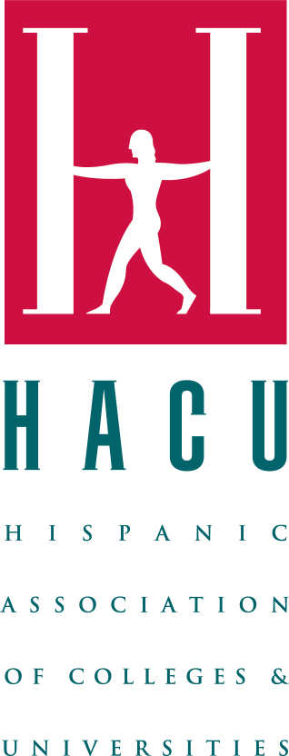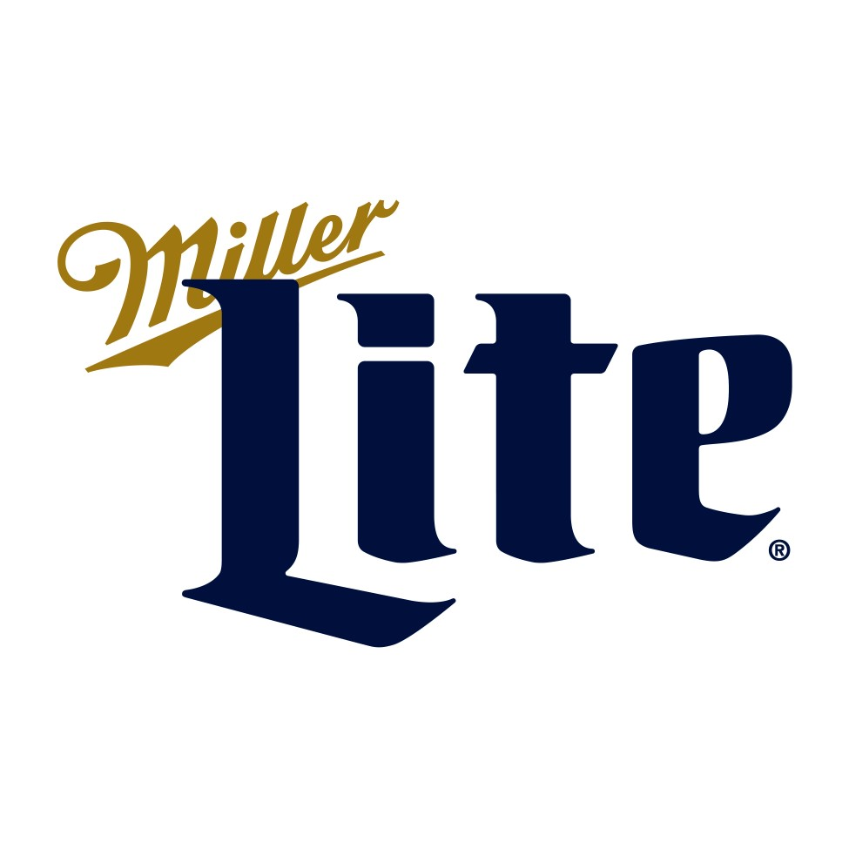

**For further information, contact:**

Sophie Gilbert sgilbert@braniganinc.com

# Applications for Miller Lite’s Brewed to Be Bright Scholarship, in partnership with the Hispanic

**Association of Colleges and Universities, are open until July 28**

*Hispanic students in the U.S. and Puerto Rico can apply for a chance to be awarded $5,000 and access to HACU's ¡Adelante! Leadership Institute*

**DALLAS – July 22, 2024 –** Building on a nearly 20-year partnership, Miller Lite and the Hispanic Association of Colleges and Universities (HACU) are collaborating once again to award scholarships and empower the next generation of Hispanic leaders. This year, 23 eligible undergraduate students will each receive a $5,000 scholarship through Miller Lite’s Brewed to be Bright scholarship program, along with career development opportunities through [HACU's ¡Adelante! Leadership Institute.](https://www.hacu.net/hacu/Annual_Conference_Student_Track.asp) Eligible Latinx students in the United States and Puerto Rico are invited to [submit an application online](https://www.hacu.net/hacu/Scholarships.asp) through July 28, 2024.

“Supporting the educational aspirations of Hispanic students is a cornerstone of our commitment to fostering a diverse and inclusive future,” said Lacey Golonka, community affairs manager, Molson Coors. “Through our collaboration with HACU, we are proud to provide scholarships that not only alleviate financial barriers but also enhance career development and leadership skills. We believe in the potential of these students to lead and innovate, and we are honored to play a part in their academic and professional journeys.”

The Miller Lite Brewed to be Bright scholarship program allocates funding to enhance educational resources, leadership development and career opportunities for students attending HACU-member institutions. By partnering with HACU, a nonprofit dedicated to improving access to and the quality of post-secondary education for Hispanic students, Miller Lite has awarded over $1 million in scholarships, supporting Latinx students in their pursuit of higher education and professional growth.

“Our partnership with Miller Lite reinforces our shared commitment to empowering students through education and career development,” said Antonio R. Flores, HACU president and CEO. “By providing these scholarships, we recognize our students’ academic excellence and pave the way for future leaders.”

Each scholarship is $5,000, for a total of $115,000 that will be awarded to Hispanic college students in California, Colorado, Florida, Illinois, New York, Texas, Wisconsin and Puerto Rico. To be eligible for consideration, students must be at least 21 years of age, enrolled as full-time or part-time undergraduate students with a GPA of 2.5 or above and studying at a two- or four-year HACUmember institution within a participating market. This scholarship is open to U.S. citizens, permanent residents and those legally authorized to work in the U.S.

If selected, scholarship recipients will also receive sponsorship to attend [HACU’s 38th ¡Adelante!](https://www.hacu.net/hacu/Annual_Conference_Student_Track.asp)

[Leadership Institute](https://www.hacu.net/hacu/Annual_Conference_Student_Track.asp) student track from Nov. 1-3, 2024, offered in conjunction with HACU’s Annual Conference in Aurora, Colorado. This three-day event serves as a platform for leadership development and networking for over 500 undergraduate students. Attendees will have the opportunity to participate in presentations, workshops and luncheons, as well as connect with conference exhibitors and recruiters. All travel expenses are included as a part of the scholarship benefit.

Visit [hacu.net](https://www.hacu.net/hacu/default.asp) for more information on the scholarships and full eligibility criteria. Applications are open now through July 28, 2024, and can be found [here.](https://www.hacu.net/hacu/Scholarships.asp)

# About Molson Coors

For more than two centuries, Molson Coors has been brewing beverages that unite people to celebrate all life’s moments. From Coors Light, Miller Lite, Molson Canadian, Carling and Staropramen to Coors Banquet, Blue Moon Belgian White, Blue Moon Light, Vizzy, Leinenkugel’s Summer Shandy, Creemore Springs, Hop Valley and more, Molson Coors produces many beloved and iconic beer brands. While the company’s history is rooted in beer, Molson Coors offers a modern portfolio that expands beyond the beer aisle as well. Our ESG strategy is focused on People and Planet with a strong commitment to raising industry standards and leaving a positive imprint on our employees, consumers, communities and the environment. To learn more about Molson Coors Beverage Company, visit molsoncoors.com, MolsonCoorsOurImprint.com or on Twitter through @MolsonCoors.

# About HACU

The Hispanic Association of Colleges and Universities, founded in 1986, represents more than 500 colleges and universities in the United States, Latin America, Spain and school districts throughout the U.S. HACU is the only national association representing existing and emerging Hispanic-Serving Institutions (HSIs). The Association’s headquarters are in San Antonio, Texas, with offices in Washington, D.C., Sacramento, California and Chicago, Illinois.

**###**